Microsoft Azure - Starter Kits for Partners

Introduction

Azure Opportunity and Business Models

Last Update: September 2015

Rev 1





**MICROSOFT MAKES NO WARRANTIES, EXPRESS, IMPLIED OR STATUTORY, AS TO THE INFORMATION IN THIS DOCUMENT.**

The information contained in this document represents the current view of Microsoft Corporation on the issues discussed as of the date of publication. Because Microsoft must respond to changing market conditions, it should not be interpreted to be a commitment on the part of Microsoft, and Microsoft cannot guarantee the accuracy of any information presented after the date of publication.

Complying with all applicable copyright laws is the responsibility of the user. Without limiting the rights under copyright, no part of this document may be reproduced, stored in or introduced into a retrieval system, or transmitted in any form or by any means (electronic, mechanical, photocopying, recording, or otherwise), or for any purpose, without the express written permission of Microsoft Corporation.

Microsoft may have patents, patent applications, trademarks, copyrights, or other intellectual property rights covering subject matter in this document. Except as expressly provided in any written license agreement from Microsoft, the furnishing of this document does not give you any license to these patents, trademarks, copyrights, or other intellectual property.

The descriptions of other companies’ products in this document, if any, are provided only as a convenience to you. Any such references should not be considered an endorsement or support by Microsoft. Microsoft cannot guarantee their accuracy, and the products may change over time. Also, the descriptions are intended as brief highlights to aid understanding, rather than as thorough coverage. For authoritative descriptions of these products, please consult their respective manufacturers.

© 2015 Microsoft Corporation. All rights reserved. Any use or distribution of these materials without express authorization of Microsoft Corp. is strictly prohibited.

Microsoft and Windows are either registered trademarks of Microsoft Corporation in the United States and/or other countries.

The names of actual companies and products mentioned herein may be the trademarks of their respective owners.

Contents

Overview 4

Cloud OS and Azure Opportunity 4

Accelerating Cloud Transformation 4

Transform the Data Center – Additional Partner Opportunities and Business Model 6

Application Innovation – Additional Partner Opportunities and Business Model 7

Big Data – Additional Partner Opportunities and Business Model 7

Enterprise Mobility – Additional Partner Opportunities and Business Model 8

Business Models for Microsoft Azure 9

Microsoft Azure - Partner Sales incentives 10

Benefits of MPN Cloud Platform competency 11

Appendix: Monetize Microsoft Azure – IDC and 10th Magnitude Study 12

# Overview

With the purpose to support our Partners to create profitable businesses while selling and deploying Microsoft solutions, we will briefly introduce what are the Microsoft Azure opportunities and some businesses models for Partners, as well sales incentives.

# Cloud OS and Azure Opportunity

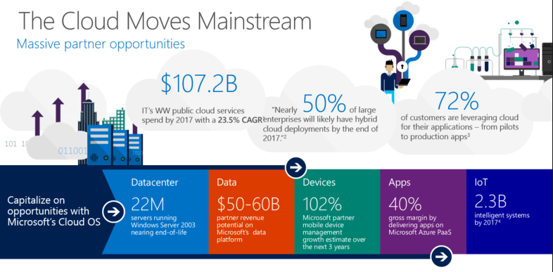

Source:

1: IDC eBook, sponsored by Microsoft, Successful Cloud Partners 2.0, May 2014  
2: Gartner Press Release, “Gartner Says Nearly Half of Large Enterprises Will Have Hybrid Cloud Deployments by the End of 2017”, October 1, 2013. <http://www.gartner.com/newsroom/id/2599315>   
3: 451 Research, Hosting and Cloud Study, 2014  
4: Microsoft Internal Analysis based on IDC data

## Accelerating Cloud Transformation

Accelerate your customers transition to the cloud with Microsoft Cloud OS – the unified platform for modern business.

But in order to drive customer business forward you must first become an expert in the cloud technology you are evangelizing.

We recommend buying and consuming an Azure EA so that you can familiarize yourself with this revolutionary cloud platform, strengthen processes internally and create your own best practices. This will enable you to craft valuable, repeatable IP based on first hand experience and become a trusted strategic consultant to your customers.

With expert knowledge under your belt you can capitalize on growing trends and opportunities in the market.

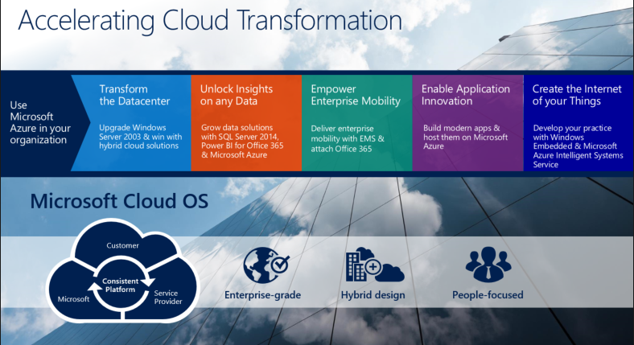

**Transform the datacenter**

For those of you who have a datacenter practice, there is a massive opportunity presenting itself. On July 15, 2015, Windows Server 2003 comes to the end-of-support (EoS). This means approximately 22 million servers worldwide are in desperate need of an upgrade. Your customers must take action. Start having conversations with them today about a remediation plan and help them make the move to Windows Server 2012 R2 and Microsoft Azure IaaS. This will also open doors to discuss enabling a hybrid environment so they can take advantage of all the benefits that cloud provides.

**Unlock insights on any data**

The volume of data is exploding. By 2020, Gartner predicts the size of the digital universe will reach 44 zettabytes, 90% of which will be unstructured data. But this volume of data is useless without the ability to collect, analyze, interpret and glean sophisticated insights from it. Microsoft grants this ability. Empower your customers with robust BI tools to get business insights faster and easier — all through the tools they use every day. It is estimated that partners will potentially generate $50-60 billion on Microsoft’s data platform. With advanced solutions for modern data warehousing, mission critical performance and big data analysis through SQL Server 2014 and HDinsights you can provide your customers with a complete data platform spanning on-premises and cloud.

**Empower enterprise mobility**

With the massive proliferation of devices, applications and users expectations of anywhere, anytime access to their data, it has become nearly impossible for IT to keep up with the ever-changing needs of modern business. Customers need your help to manage the increasing complexity. With Office 365 and the new Enterprise Mobility Suite from Microsoft, you can simplify IT, enable productivity, protect users’ data and unify their environments with a complete, managed solution. Based on our conversations with partners offering these solutions to customers, they expect growth metrics in their businesses as high as 131% for Identity and Access Management, 102% for Mobile Device Management and 76% for Desktop Management over the next 3 years. These explosive growth numbers indicate the market is ripe for enterprise mobility solutions. Be the one to provide it to them.

**Enable application innovation**

IDC predicts by 2017, nearly $1 of every $5 spent on applications will be consumed via the cloud. Ensure that you are building your applications on Microsoft Azure. Partners who are delivering their applications on Microsoft Azure PaaS are realizing gross margin of 40% on average.

**Create the internet of your things**

With trillions of things to be connected where do customers turn? To you of course. Microsoft partners have a unique opportunity to connect customers’ sensors and end-point devices to databases, driving strategic insights within their businesses. Provide customers with a connected ecosystem of devices and holistic views of their data with intelligent systems enabled by Windows Embedded and Microsoft Azure.

So how can you address all of these customer needs and take advantage of the opportunities in the market? The answer is by developing solutions on Microsoft’s Cloud OS platform.

Cloud OS is an enterprise-grade, hybrid designed, people-focused platform that bridges the gap between you, Microsoft and your customers. All on one consistent platform.

**Enterprise-grade**

Global reach, scale and security to meet business demands

**Hybrid design**

One consistent platform across multiple environments and clouds

**People-focused**

Expand tech skillset to the cloud for new innovation

## Transform the Data Center – Additional Partner Opportunities and Business Model

**Hosting Service Providers**

There are a number of ways to take advantage of Cloud OS for you datacenter practice.

* + **Profit** with targeted and differentiated offers
  + Unmanaged VM hosting
  + Managed VM hosting
  + Hosted Database
  + Database-as-a-Service
  + **Develop packaged (bundled) offerings** to deliver unique solutions

**Independent Software Vendors**

* **Port your applications** to Windows Server and make them cloud ready
* **Build cloud & hybrid apps** and certify them: Azure Certified Program
* **Modernize apps and upgrade customers** on Windows Server 2003 and SQL Server 2005

**Licensing Solution Provider**

* **Sell** SCE enrollments
* **Sell** Azure EA and deploy
* **Capitalize** on growing hybrid and cloud opportunities
* **Expand** to your business to managed services
* **Build more** repeatable IP and value-add services

**Original Equipment Manufacturer**

* **Sell** new, high performing servers running Windows Server 2012 R2 Datacenter for highly virtualized and hybrid cloud environments
* **Differentiate** with targeted hardware, software, and support offerings

**Build** and sell private/hybrid cloud solutions with Fast Track Program

## Application Innovation – Additional Partner Opportunities and Business Model

For Independent Software Vendor-ISVs, we recommend:

* Modernize your applications on the Microsoft platform
* Build cloud and hybrid applications on Microsoft Azure PaaS for maximum gross margin
* And certify your applications on Microsoft Azure

For Managed Service Provider - MSPs:

* We suggest, expanding your business to managed services with your applications and Microsoft cloud services
* And build more repeatable IP and value-add services

Finally, for Managed Service Provider-LSPs we recommend:

* Selling Microsoft Azure EA and SCE
* Package and resell Microsoft cloud services and partner applications
* Build more repeatable IP and value-add services
* And expand your business to managed services with your applications and Microsoft cloud services

## Big Data – Additional Partner Opportunities and Business Model

For ISVs, we recommend:

* Building your BI and Cloud BI, Mobile BI, and big data applications on the Microsoft data platform
* Deliver mission critical applications with In-Memory OLTP
* Modernize your applications with SQL Server 2014 In-Memory and Microsoft Azure

For LSPs, we recommend:

* Driving SQL Server upgrades to SQL Server 2014
* Sell SCE enrollments and cross sell Power BI for Office 365
* Expand with repeatable solutions and IP with the Microsoft data platform
* Expand your business to build repeatable solutions and IP
* And, Drive profitability with data related offering

For Hosting Service Providers:

* Profit with targeted and differentiated offers
  + Hosted database
  + Database as a Service
  + Upgrade from older versions of SQL Server and offer modern hosting services with SQL Server 2014

And finally, OEMs should:

* Create new revenue streams and offer SQL Server on new hardware preinstalled

## Enterprise Mobility – Additional Partner Opportunities and Business Model

**Managed service providers**

* **Lead** & monetize on COIT/BYOD trends
* **Adopt** EM technologies for MSP RMM
* **Win** business from large outsourcers
* **Boost** revenue with subscriptions model & sell devices

**Licensing Solution Provider**

* **Lead** & monetize on COIT/BYOD trends
* **Evolve** license sales to subscriptions model & sell devices
* **Build** on existing skills
* **Expand** into the Managed Services business

**Hosting Service Provider**

* **Offer** Hosted Desktop solutions
* **Provide** entry, mid-level, and premium/vertical desktop hosting options
* **Deliver** premium desktop offerings (including vertical)
* **Manage** apps (e.g., QuickBooks) and add-ons (e.g., DR, anti-virus)

# Business Models for Microsoft Azure

There are two basic models depending if it is Partner or Customer who purchases the Microsoft Azure subscription and therefore has a billing relationship with Microsoft. It is common for ISV Partners to own the Azure subscription as they offer to customers their solution (typically a web based application) as a Software as a Service (SaaS). The Customer typically is not aware of where the software is hosted. He pays a subscription fee (typically per user per month) for the service. In this model, the Partner has to ensure that the Azure infrastructure costs (virtual machines.) required to run the software and the variable costs derived from the user activity (bandwidth, storage costs) can be recovered from the subscription revenue he receives. It is easier to do that, if it is possible to share parts of the Azure infrastructure to deliver the software to multiple customers. SaaS developed by ISVs as well as multi-tenant services delivered by hosting partners acting as Service Providers would fall into that category (for a technical example of multitenant hosting see

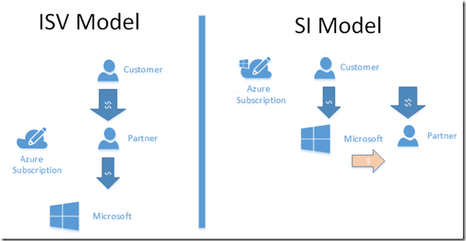

In the second model, the Customer owns the Microsoft Azure subscription and has a billing relationship with Microsoft. This model can typically be found with System Integrators (SI) that help customer to move their infrastructure to the Cloud. Apart from the consultancy fees for the execution of the project, there is an opportunity for partner to provide value added services such as backup and recovery services, reporting, monitoring, capacity planning, disaster recovery, IT outsourcing and management for a recurring revenue. For Partners that commit to this model, Microsoft offers sale incentive (see below) that is a percentage of Azure consumption that his Customers generate during a specific time period.

There is nothing stopping any one Partner to have relationships with various Customers in one or the other model.  
  
In the picture below, we have another great representation of the possible business models in Azure. 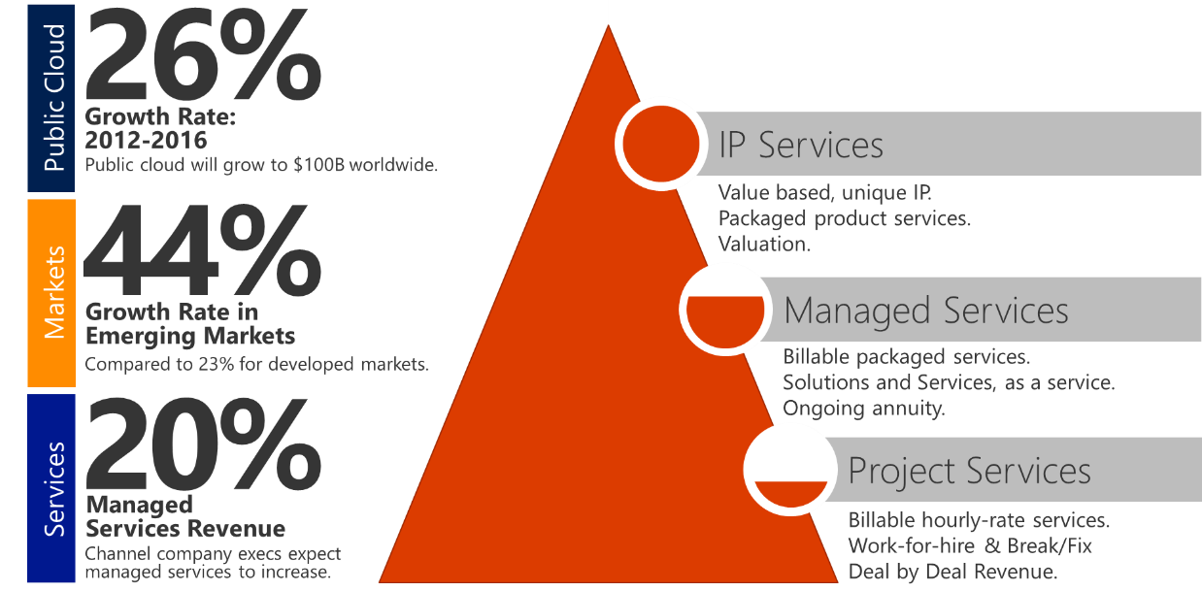  
Source: WPC 2013 - Partner Practice Builder, by Jennifer Stockton

# Microsoft Azure - Partner Sales incentives

The Microsoft Azure Incentives rewards partners for driving consumption of Microsoft Azure Services on Microsoft customer subscriptions purchased through the Microsoft Online Services Agreement (MOSA) and Enterprise Agreements (Enterprise (EA), Enterprise Subscription (EAS), Campus and School (CASA/EES), MS Led (mainland China)) only. Microsoft Azure is a flexible Cloud platform that enables customers to develop, deploy, and manage applications across a global network of Microsoft-managed datacenters. Partners play a critical role in helping Microsoft Azure customers develop new applications and migrate existing applications to Microsoft Azure. The guide below summarizes the requirements to participate in the Microsoft Azure Incentives. It replaces and supersedes all prior Microsoft Azure Incentives Guides and any related communications. All links referenced throughout the Guide will be available in the Resources section of this guide.

Partner obtains money for migrating customers’ infrastructure and for value-added services, he may be offering. Microsoft offers sales incentives in this model where the Partner will receive a percentage of the influenced Customer revenue during a period of 2 years. You can find all the details and conditions in “[Microsoft Azure incentive guide](https://mspartner.microsoft.com/en/us/Pages/Membership/Premium/partner-incentives.aspx#Microsoft-Azure- incentives)” on Microsoft Partner Network site. Starting January 2014 the incentives requires a MPN a Cloud competency.   
  
More details about incentives at [MPN – Partner Incentives Page for Azure](https://mspartner.microsoft.com/en/us/Pages/Membership/Premium/partner-incentives.aspx#Microsoft-Azure- incentives)

**POR**: Starting August 1, 2015, customers can go into the Azure Account Portal to identify the partner that is driving consumption for a given Azure subscription. Please reference the Azure Incentives Implementation Guide for more details.

# Benefits of MPN Cloud Platform competency

A set of core benefits is provided to all partners each time they enroll or renew their membership in the Microsoft Partner Network. Visit the [core benefit and requirements](https://mspartner.microsoft.com/en/us/pages/membership/core-benefits.aspx) page to see the complete list. Review the following table for a list of benefits and requirements specific to this competency.

|  |  |  |
| --- | --- | --- |
| **Benefits** | **Silver** | **Gold** |
| Microsoft Azure internal-use software licenses | US$250 per month Azure credit.   (on top of US$100 monthly Azure credit from the competency core benefit) | US$500 per month Azure credit.   (on top of US$100 monthly Azure credit from the competency core benefit) |
| Access to the Cloud Platform Roadmap, a comprehensive look at our current and future technology plans | https://mspartner.microsoft.com/en/SiteCollectionImages/rwd/competency-circle-1.png | https://mspartner.microsoft.com/en/SiteCollectionImages/rwd/competency-circle-1.png |
| Unlimited Signature Cloud Support | https://mspartner.microsoft.com/en/SiteCollectionImages/rwd/competency-circle-1.png | https://mspartner.microsoft.com/en/SiteCollectionImages/rwd/competency-circle-1.png |
| Eligibility for Azure Deployment Planning Services. [Learn more about AZDPS.](http://planningservices.partners.extranet.microsoft.com/en/AZDPS/pages/default.aspx) | https://mspartner.microsoft.com/en/SiteCollectionImages/rwd/competency-circle-1.png | https://mspartner.microsoft.com/en/SiteCollectionImages/rwd/competency-circle-1.png |
| Marketplace/Pinpoint Prioritization | https://mspartner.microsoft.com/en/SiteCollectionImages/rwd/competency-circle-1.png | https://mspartner.microsoft.com/en/SiteCollectionImages/rwd/competency-circle-1.png |
| Direct partner support provided by a regional contact or tele partner account manager | https://mspartner.microsoft.com/en/SiteCollectionImages/rwd/competency-circle-2.png | https://mspartner.microsoft.com/en/SiteCollectionImages/rwd/competency-circle-1.png |
| Eligibility to deploy certain on-premises, internal-use software on Microsoft Azure. [Learn more about IUR Mobility](https://assets.microsoft.com/en-us/mpn_iur_mobility_term_1.pdf) | https://mspartner.microsoft.com/en/SiteCollectionImages/rwd/competency-circle-1.png | https://mspartner.microsoft.com/en/SiteCollectionImages/rwd/competency-circle-1.png |

<https://mspartner.microsoft.com/en/us/pages/membership/cloud-platform-competency.aspx>

# Appendix: Monetize Microsoft Azure – IDC and 10th Magnitude Study

Many Microsoft partners are capitalizing on the growing cloud services market by building successful practices on Azure, and the latest IDC research shows that cloud-oriented partners are outperforming their peers by growing more quickly and profitably.

“Partners with more than half their business from cloud generate 1.6X more recurring revenue than other partners.” - IDC InfoDoc, Sponsored by Microsoft. "Successful Cloud Partners 2.0: What IT Solution Providers Need to Know to Build High-Performing Cloud Businesses" April 2014

* **Get ahead of the curve** – Early cloud adopters are significantly outperforming their non-cloud-oriented peers. With the cloud market expected to grow to $76.1 billion by 2017, now is the time to get started.
* **Choose a target** – Focus on one of two paths: small and midsize customers with a breadth offering, or go deep with large enterprises. Pick a strategy and stick with it.
* **Prepare for the transition** – A short-term decrease in revenue is normal during the transition from project-based business models to recurring revenue models, but the long-term rewards—faster revenue growth, increased profitability, and higher levels of new customer acquisition—are well worth it.

[Learn More – Read the Complete study](https://partner.microsoft.com/download/global/40197183)